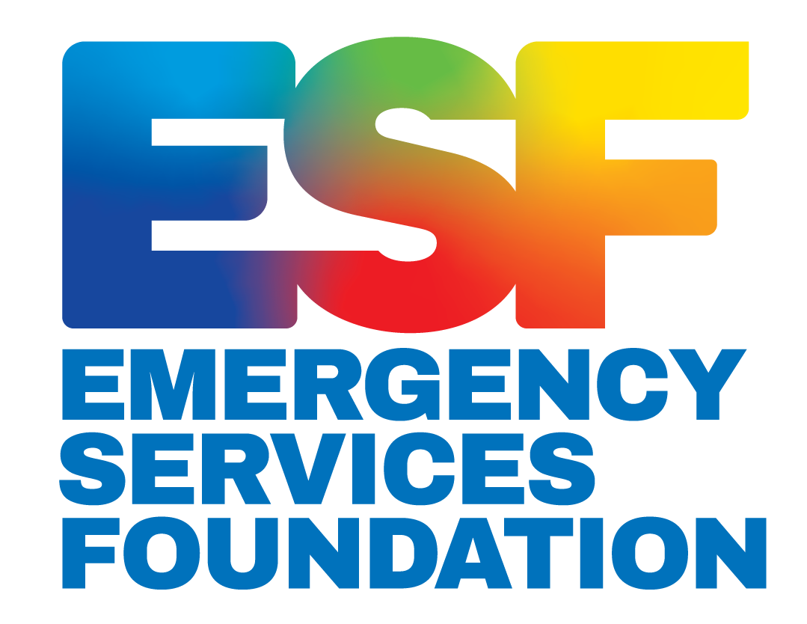
More Than “Thank You”:
Recommendations For a Volunteer Recognition Program For the Victorian Emergency Services Sector

Sponsored by the Emergency Services Foundation

Authors:
Dylan Connors
Dan DiVecchia
Karen Ho

Advisors:
Professor Lorraine Higgins, WPI
Professor Uma Kumar, WPI

Project Work: October 21 - December 11, 2020

Supplementary Materials for an Interactive Qualifying Project submitted to the Faculty of Worcester Polytechnic Institute in partial fulfillment of the requirements for the Degree of Bachelor of Science.​
Table of Contents
Supplemental Material-A: Author Contributions 3
Supplemental Material-B: Meeting/Interview Log 3
Supplemental Material-C: Organizations of Interest 4
Supplemental Material-D: Forms of Recognition/New Ideas Masterlist 5
Supplemental Material-E: Forms of Recognition: Organization Examples 8
Supplemental Material-F: Interview/Focus Group Preamble 11

Supplemental Material-A: Author Contributions
 |  | Dylan | Dan | Karen
Chief Editor
Abstract
Acknowledgements
Introduction (A Need for Volunteer Recognition)
Background
The Psychology of Volunteerism and the Desire for Recognition
The Demands Placed on Emergency Service Volunteers
Occupational Trauma and a High Prevalence of Mental Health Problems in the Emergency Services Sector
The Emergency Service Foundation (ESF)
The Positive Impact of Recognition on Worker Wellbeing and Retention
Ways to Recognize Volunteers: Two Major Forms of Recognition
The Role of Leadership in Volunteer Recognition
Current Formal Recognition Programs
Current Informal Recognition Programs
Methods and Results
Roles and Experiences of Volunteers
Importance of Volunteer Recognition
Qualities & Components of a Good Recognition Program
Determine Strategies Most Appropriate for and Welcomed by Volunteers
Manager's Perspective
Volunteers Perspective
Summary of Results
Recommendations
Conclusion
* Lighter shades mean worked on together

Supplemental Material-B: Meeting/Interview Log
Contact | Organization, Position/Description | Meetings
Tony Pearce | IGEM (Inspector General for Emergency Management) | 10/4
Martin McKinnon | Personal Friend of Ms. MacKenzie  Working to create a discount card program for volunteers | 10/7  11/24
Faye Bendrups | Victoria SES Volunteers Association, President  National SES Volunteers Association, Vice Chair | 10/8
Emma Atkins | Life Saving Victoria (LSV), General Manager - People | 10/25
Michael Downing  Kellie Shewring | Victoria Council of Churches (VCC)  Workforce Manager  CEO | 10/25
Dave Garner | Ambulance Victoria (AV), First Responders Manager | 10/26
Margaret McCarthy | Red Cross Australia, Coordinator Capability and Capacity - Melbourne | 10/26
Robert Wilson | St John Ambulance | 10/27
Raelene Williams  Roz Long  Niki Habibis  Leanne Blenkiron | Country Fire Authority (CFA),  Volunteer Sustainability Manager  Community Engagement Officer  Training Coordinator  Regional IMT Capability Coordinator | 10/27
Ben W Penrose | Emergency Management Victoria Marine Search and Rescue (EMV MSAR) | 10/28
Andrew Crisp | Emergency Management Victoria (EMV), Commissioner | 10/29
Priscilla Grimme | Victoria State Emergency Service (VicSES), Volunteer Support Officer | 10/29
Carina Newton | ESF Scholarship Alumni  VicSES Section Leader - Work Health Safety & Wellbeing, North East (Hume) Region | 11/2
David Lawrence | University of Western Australia, Associate Professor | 11/4
Marcus Warner | ESF Scholarship Alumni  VicSES Deputy Controller – Bright Unit | 11/5
Sue Foley | Rotary Club | 11/24

Supplemental Material-C: Organizations of Interest
Australian/International Organizations | Emergency Service Organizations within Victoria
- Red Cross | - Ambulance Victoria (AV)
- Special Olympics of Australia | - Country Fire Authority (CFA)
- United Nations (UN) | - Victoria State Emergency Service (VicSES)
- Peace Corps | - Life Saving Victoria (LSV)
- Smith Family | - Victoria Council of Churches - Emergency Management (VCCEM)
- Cal Fire | - Red Cross

Supplemental Material-D: Forms of Recognition/New Ideas Masterlist

Form | Examples | Informal/Formal/Both? | Notes
Praise/thanks | Positive feedback from:  - supervisors  - peers  - people affected by work | Both | Can be formal if published
 | Acknowledgement of achievements/milestones  (eg, verbal, posting names to website) | Both | Can be formal if published
 | Certificates | Formal
 | Prestigious Awards | Formal
 | Banquets | Formal | Formal, but the social aspect is welcomed
 | Memory items | Both | Depending on presentation method
Displays of respect/support | Being granted shared authority | Informal
 | Being involved in decision making | Informal
 | Opportunities for professional development | Informal
 | Freedom to pursue ideas for organization improvement | Informal
 | Lunch with leadership | Informal
 | Peer support  (e.g., support after difficult shifts) | Informal
 | Check-ins from supervisors/leaders  (e.g., consideration of personal situations, training progress, confidence in abilities) | Informal
Learning about impact of work | Letters/cards from people they have helped | Informal
 | Published newspaper articles showing the impact of work as well as the sacrifices made | Formal
 | Stories on website defining the impact of work with interwoven volunteer appreciation | Formal
 | Updates from organization/supervisor  (e.g., newsletters w/ # of people helped that month) | Both
Improve Social Media | Verified | Formal
 | Stronger Advertisement | Formal
Discount Program | e.g., Member Link | Formal
 | New Program | Formal | McKinnon
 | organizations join and provide discounts as it is positive for business if they show support of the volunteering community | Formal
Newspaper/Local Paper  How has the volunteer work made an impact | Use of story telling with work of volunteers interwoven into the writing. Allows the volunteer to feel recognized while not being singled out. | Formal
 | Use of powerful images | Formal
 | Impact report emails could also be sent to volunteers highlighting the impact of their work | Informal
 | main message is to convey the sacrifice the volunteers make | Formal
Supervisor training regarding recognition | regular individual meetings between supervisors and volunteers were appreciation can be expressed and volunteers can explain comments, questions, or concerns | Informal
 | Simple things managers can do to support wellbeing of volunteers | Informal
School Children Appreciation | Card creation in class for volunteers | Formal
 | How these children have been impacted by the volunteer work | Both
 | Potential for children to make card for family members | Informal
School presentations to student audience by volunteers | Students see the work of the volunteers | Formal
 | potential for recruiting | Formal
 | Opportunity for students to informally thank these volunteers | Informal
 | volunteers get a chance to show what experiences they must endure | Formal
Involvement in parades |  | Formal
Donate in volunteers name to charity | Organizations donate in the names of volunteers to organizations that they desire when they have performed outstanding actions or achievements | Formal
Open House/Expo | Volunteers able to interact with community members in informal conversations | Informal
 | Fire Museum location | Both | fosters informal
 | Families of volunteers able to interact as well | Informal
 | Deeper connections within the volunteer organization can be made | Informal
Provide a Job Reference program | Volunteers will be able to gain valuable relationships with coworkers and become closer with one another | Formal | Social Aspect
 | Will be used by Volunteers for paid positions and make it easier for them to find new jobs and meanings
Sporting/ Entertainment events | season ticket holders able to donate tickets | Both | depends on framing
 | public recognition events at games (create a structure for these organizations to contact and work with volunteer orgs easier) | Formal

Supplemental Material-E: Forms of Recognition: Organization Examples
Organizations | Formal | Informal | Other | Additional Comments
Red Cross | - Certificate of Merit Award  - Red Cross Life saving Award  - Marine Rescue Hero  -Wilderness Rescue Hero  -Transportation Safety Hero | - personal appreciation by manager  - personal phone calls  - manager-->volunteer relationships  - Explanation on impact of work |  | The Red Cross is a model  Organization strong forms of  recognition both formally and informally.  This organization is applicable as it is a  emergency response organization that  can be applied to the Victorian  Emergency Service Sector.
UN | - Online Volunteering Award  -Sheikh Isa bin Khalifa Award for  Volunteer Work  - International Volunteer day | Unknown |  | The UN provides a solid foundation for a  formal recognition program although the extent  of the UN's use of informal Recognition is  unknown.
Special Olympics of Australia | -Athlete of the Year  -Young Athlete of the Year (16 - 26 years old)  -Coach of the Year  -Young Coach of the Year (16 - 26 years old)  -Volunteer of the Year  -Young Volunteer of the Year (16 - 26 years old)  -Community Hero | -Managers and supervisors use a wide array  of informal methods including but  not limited to personal thank yous  -this comes from both the volunteer managers  and the athletes and others | This organization is model in the use of a new form of recognition. They use the method of showing the volunteers how their work has made an impact. On the website they have stories that show positive impact that the volunteer work has had on the athletes. The volunteers are not singled out but the appreciation is interwoven into the response. | This organization shows strong forms of informal appreciation  this comes from the athletes as well as others within  the organization. Additionally there method of showing the  volunteers how there work has made a difference is very  successful as well.
Peace Corps | -Incentive Rewards Program  -Paul D. Coverdell Fellows Program  -Sargent Shriver Award  -The Loret Miller Ruppe Award  -Harris Wofford Global Citizen Award | Unknown |  | The Peace Corps have many forms of formal recognition that is publicized but has little to none public information shown of informal recognition. If able to speak with a representative, What is the retention rate of your volunteers like? Are the people returning older or younger?
Volunteer Australia | -Collaboration Community Impact Award -Employee Volunteer Program Award -Excellence in Grassroots Organisation Award -Inclusion Award | -"Provide a warm welcome for each new volunteer  -Ask volunteers for their opinions when developing new policies and strategies  -Involve volunteers in morning teas and coffee breaks" |  | Volunteering in Australia is vital to the sustainability of Australia and the emergency service sector, without volunteering natural disaster will go unattended. Volunteer Australia has multiple programs in place, however, they lack a strong informal approach, the informal category was just merely suggestion they had but had yet to actively implement
The Smith Family | -Sponsors receive a profile written by their sponsored child  -Tax deduction slip for any donations  -Welcome Packet | - Opportunity to write to their sponsored student

Supplemental Material-F: Interview/Focus Group Preamble
The purpose of this study, sponsored by the Emergency Services Foundation (ESF) of Victoria, Australia, is to determine possible forms of recognition that may help improve the wellbeing of emergency service volunteers. We are particularly interested in how volunteers feel about being acknowledged for their work and what forms of recognition they desire the most. Recommendations for a recognition program will be made based on the information gathered.
Study results will be published on our university website (WPI) and shared with ESF administration. If you choose to participate in this interview you are free to end the interview at any time and you can choose to not answer any questions. You will not be identified by name in the report, but by a pseudonym associated with your organization (ex. CFA Volunteer 1). If you wish to have your interview removed from our records after your interview, please contact us at the email address provided and we will do so.
By remaining on this video call, you acknowledge your willingness to participate in the interview, which should take approximately 1 hour. Audio from the interview will be recorded, but will not be available to anyone outside of our research team and will only be used for the sake of this study.
If you have further questions about this study or wish to read our final report, please contact us at gr-ESFB20@wpi.edu or our WPI faculty advisors at ldh@wpi.edu (Prof. Lorraine Higgins) and kumar@wpi.edu (Prof. Uma Kumar).
Thank you for your participation.

